**What is DNS? What is the use of DNS server? And how to do setup?**

* Domain Name System (DNS) is a system in which there is conversion of Ip addresses into simple name so that it is easy for user to access it. Normally its difficult to remember ip addresses of the system that’s why dns server comes to use.

Setup of DNS server in vmware workstation where it has 2 servers i.e. of centos 7

Requisite :

* OS : **Centos7**
* Ip address :
* Dns server:**192.168.47.130/24**
* Dns client**: 192.168.47.131/24**
* Dns server host name : **server.dns.com**
* Dns client host name : **client.dns.com**
* Domain name of dns server: **dns.com** and subdomain name : **server**
* Domain name of client server**: dns.com** and sub-domain name : **client**

1. We have to install bind and bind-utils packages:

**dnf install bind bind-utils**

1. Once successfully installed, start the DNS server using the command below:

**Systemctl start named**

1. Next, enable it so that it can kick in even after a reboot

**Systemctl enable named**

1. To check status whether its running :

**Systemctl status named**

(but before that u have to disable the firewall settings )

1. Configure the bind Dns server:

The bind configuration file located in **/etc/named.conf**

* So first of all you have to take the backup of the by default configuration file so that the original file will not get affected. So for backup u can run command:

**Cp /etc/named/named.conf /etc/named/named.bak**

Now go ahead and open the file using your vi text editor

**Vi /etc/named/named.conf**

Under this file only change the allow query which is on line no. 21

**allow query {localhost; 192.168.47.0/24; };**

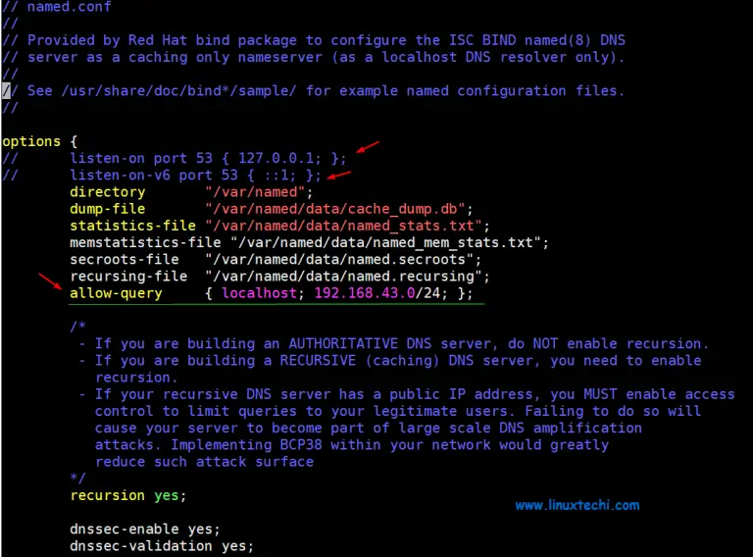

This setting allows only the hosts in the defined network to access the DNS server and not just any other host.

A**forward lookup DNS zone** is one that stores the host name ip address relationship. When queried, it gives the IP address of the host system using the host name. In contrast, the **reverse DNS zone** returns the **Fully Qualified Domain Name (FQDN)** of the server in relation to it’s IP address.

* To define the reverse and forward lookup zones, copy and paste the following configuration at the end of **/etc/named.conf**
* //forward zone
* zone "dns.com" IN {
* type master;
* file "server.dns.com.db";
* allow-update { none; };
* allow-query { any; };
* };
* //backward zone
* zone "47.168.192.in-addr.arpa" IN {
* type master;
* file "dns.com.rev";
* allow-update { none; };
* allow-query { any; };
* };

After saving, exit the /etc/named.conf configuration file

**Type:** Stipulates the role of the server for a particular zone. the attribute ‘master’ implies that this is an authoritative server.

**file**: Points to the forward / reverse zone file of the domain.

**allow-update:** This attribute defined the host systems which are permitted to forward Dynamic DNS updates. In this case, we don’t have any.

* Create a forward DNS zone file

**Vi /var/named/dns.com.db**

**Then configure as follows:**

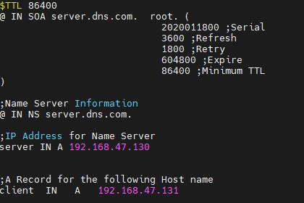

**Let’s define some of the parameters indicated in the configuration file:**

* **TTL: This is short for Time-To-Live. TTL is the duration of time (or hops) that a packet exists in a network before finally being discarded by the router.**
* **IN: This implies the Internet.**
* **SOA: This is short for the Start of Authority. Basically, it defines the authoritative name server, in this case, dns-primary.linuxtechi.local and contact information – admin.linuxtechi.local**
* **NS: This is short for Name Server.**
* **A: This is an A record. It points to a domain/subdomain name to the IP Address**
* **Serial: This is the attribute used by the DNS server to ensure that contents of a specific zone file are updated.**
* **Refresh: Defines the number of times that a slave DNS server should transfer a zone from the master.**
* **Retry: Defines the number of times that a slave should retry a non-responsive zone transfer.**
* **Expire: Specifies the duration a slave server should wait before responding to a client query when the Master is unavailable.**
* **Minimum: This is responsible for setting the minimum TTL for a zone.**
* **MX: This is the Mail exchanger record. It specifies the mail server receiving and sending emails**
* **CNAME: This is the Canonical Name. It maps an alias domain name to another domain name.**
* **PTR: Short for Pointer, this attributes resolves an IP address to a domain name, opposite to a domain name.**
* Create a reverse DNS zone file

**Vi /var/named/dns.com.rev**

**Configure as per below:**

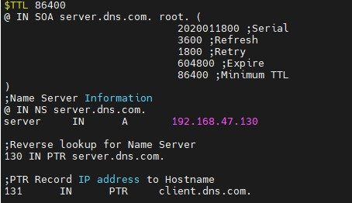

* Next, assign the necessary file permissions to the two configuration files.

Run the following commands :

**chown named:named /var/named/dns.com.db**

**chown named:named /var/named/dns.com.rev**

* To confirm that the DNS zone lookup files are free from any syntactical errors, run the commands shown:

**named-checkconf**

**named-checkzone dns.com /var/named/dns.com.db**

**named-checkzone 192.168.47.130 /var/named/dns.com.rev**

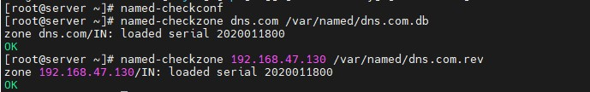

* For the changes to be reflected in the system, restart the Bind DNS server

**systemctl restart named**

* **After System restart then go the the client server and configure as follows :**

On a client machine ( CentOS 7)(192.168.47.131), open the **/etc/resolv.conf** file and edit the following parameter:

**nameserver 192.168.47.130(write these parameters on 3nd line and save the file).**

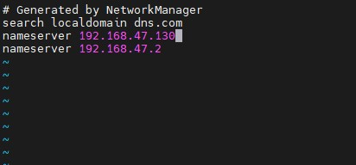

* **Run the following commands :**

**dig server.dns.com (you will be seeing the following output)**

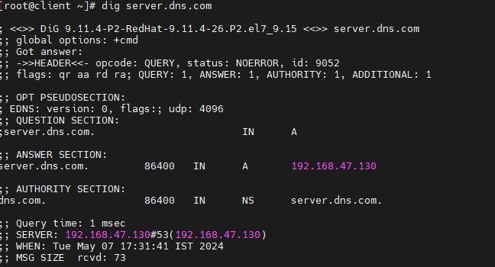

**dig -x 192.168.47.130**

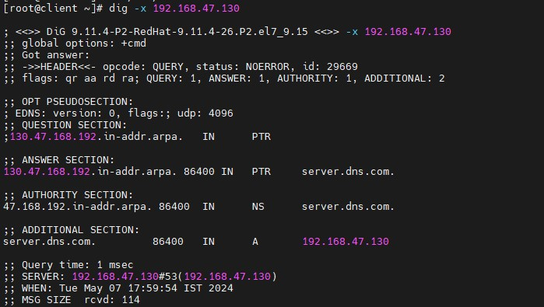

* **After that you have to restart the network manager**

**systemctl restart NetworkManager**

* **After restart of Network manager u will realise that when u r performing dig commands then it will not show any output. The screen would displayed as like this :**

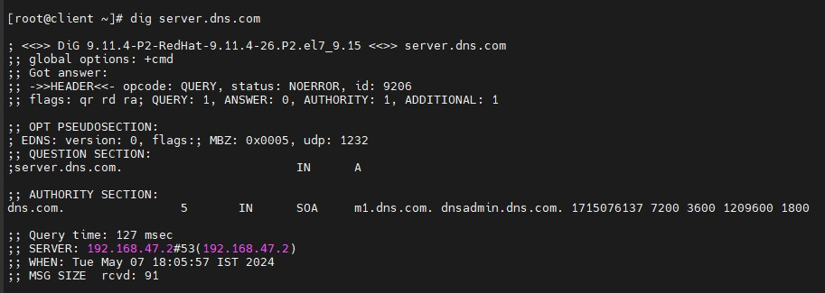

* **The reason is simple we were performing temporary changes so that we can get an output.**

**Error and Troubleshoot**

* **Error 1:**

Confusion in hostname of the machines i.e, dns server and dns client:

To avoid the confusion we set the hostname of dns server i.e.,(server.dns.com) and for dns client (client.dns.com)

We set the hostname by running the commands:

hostname

hostnamectl set-hostname server.dns.com

* **Error 2:**

Appeared at the time of running the restart named service

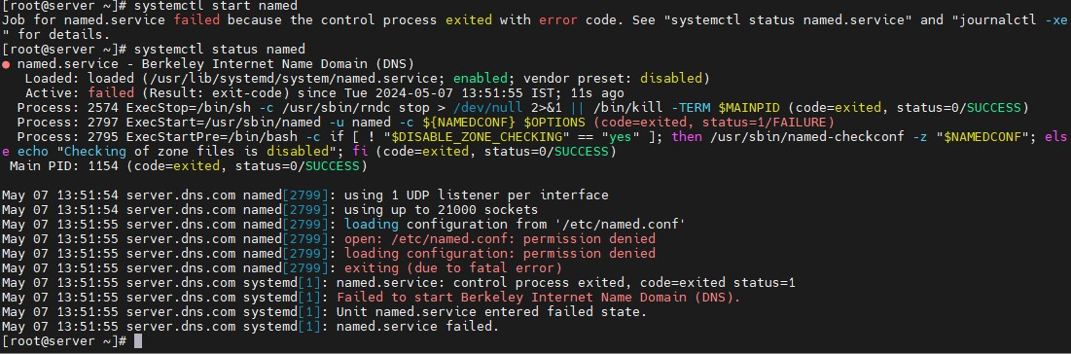

This error arised due to ownership of root. So to troubleshoot that error we changed the ownership to named. As mentioned below:

**Run ll command**

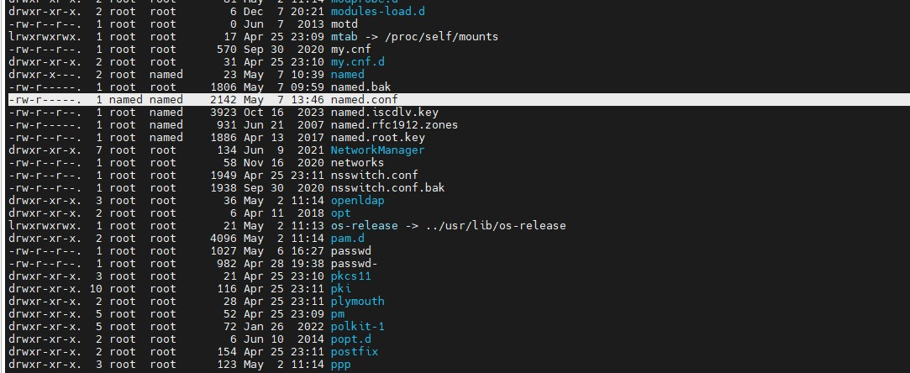

* This was the two major errors that I faced during setup.
* I also face the errors that occurred due to confusion of hostname, domain name and Ip address and subnet concepts.